Nekton SAC Committee

Guy Freeman - Diving Officer Bob Prior - Chairman
BSAC Dive Leader
Advanced Nitrox & Accelerated Deco.
Diving for 17+ Years
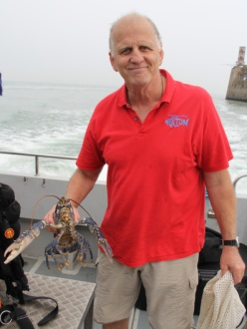
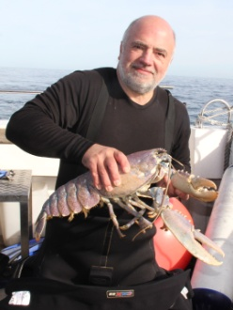
BSAC Advanced Diver
Open Water Instructor
RYA Level 3 Powerboat Qualified
Advanced Nitrox & Accelerated Deco.
Diving for 21+ Years

Jackie Simmons - Training Officer Jeremy Swann - Expeditions Officer
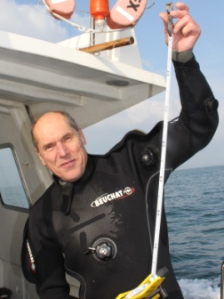
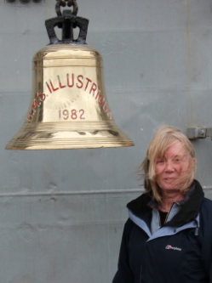
BSAC Advanced Diver
Open Water Instructor
RYA Level 2 Powerboat Qualified
Advanced Nitrox & Accelerated Deco.
Diving for 28+ Years

BSAC Advanced Diver
Open Water Instructor
Nitrox Qualified
Diving for 20+ Years

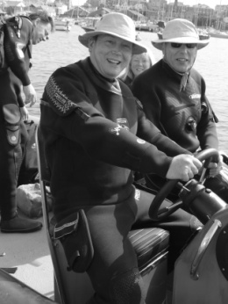
Barry Barlow - Treasurer Justin Williams - Secretary
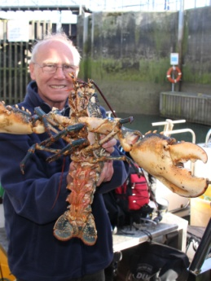
BSAC Club Diver
Nitrox Qualified
Diving for 11+ Years
BSAC Advanced Diver
Open Water Instructor
Advanced Nitrox & Accelerated Deco.
Diving for 14+ Years

